Configuring the API Gateway and Live API Creator (LAC) in Google Cloud Platform (GCP) - Kubernetes

Summary

The following steps will help you deploy API Gateway and Life API Creator in Google Cloud Platform (GPC) Kubernetes environment.

Sign up for a free GCP account.   
You can sign up for a Google Cloud Platform account free for 12 months – up to $300 credit. Once you are done testing/demoing make sure you delete the Kubernetes Cluster to avoid accumulating charges.

Create a new project   
Create a new project for your new Kubernetes Cluster. In the example below the project name is API.

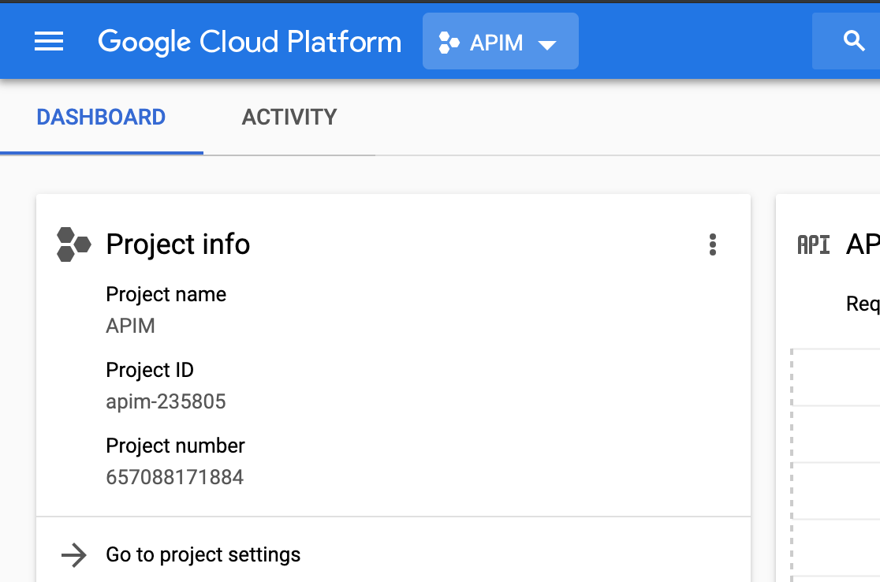

Create a Kubernetes Cluster in GCP  
This is the cluster that will host the Gateway, MySQL and LAC services. The Gateway and MySQL services will have its own Kubernetes Pod. These two services will make up the API Gateway application. The LAC will be on its on Pod. For this demo Kubernetes cluster use the following compute resources: One member, 2 vCPUs and 7.

* Go to Kubernetes Engine - Clusters – Create cluster
* Choose “Your first cluster”
* Choose the Zone closest to your location (in this example we chose us-west1-a)
* In Machine Type change to 2 vCPUs and 7.5GB Memory
* Leave everything else un-changed and click on “Create”

Alternately you can use a command as shown below. Cut and paste it in the “Cloud Shell”:

$gcloud beta container --project "compact-gadget-123905" clusters create "your-first-cluster-1" --zone "us-west1-a" --username "admin" --cluster-version "1.11.7-gke.12" --machine-type "n1-standard-2" --image-type "COS" --disk-type "pd-standard" --disk-size "30" --scopes "https://www.googleapis.com/auth/devstorage.read_only","https://www.googleapis.com/auth/logging.write","https://www.googleapis.com/auth/monitoring","https://www.googleapis.com/auth/servicecontrol","https://www.googleapis.com/auth/service.management.readonly","https://www.googleapis.com/auth/trace.append" --num-nodes "1" --enable-cloud-logging --enable-cloud-monitoring --no-enable-ip-alias --network "projects/compact-gadget-123905/global/networks/default" --subnetwork "projects/compact-gadget-123905/regions/us-west1/subnetworks/default" --addons HorizontalPodAutoscaling,HttpLoadBalancing --enable-autoupgrade --enable-autorepair

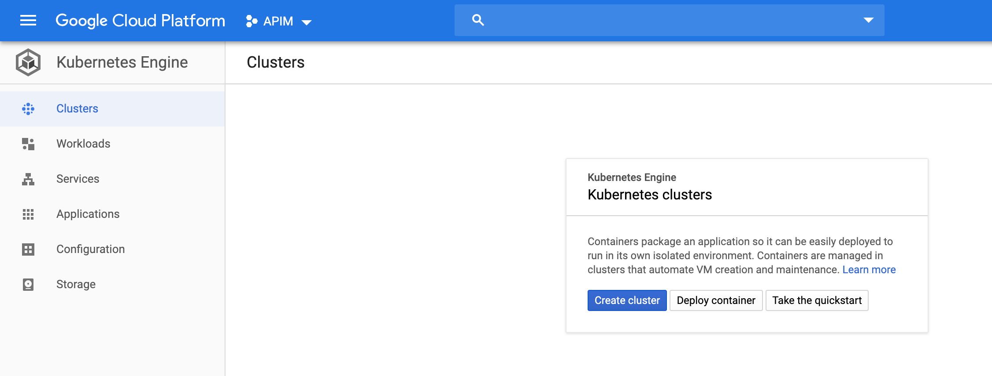

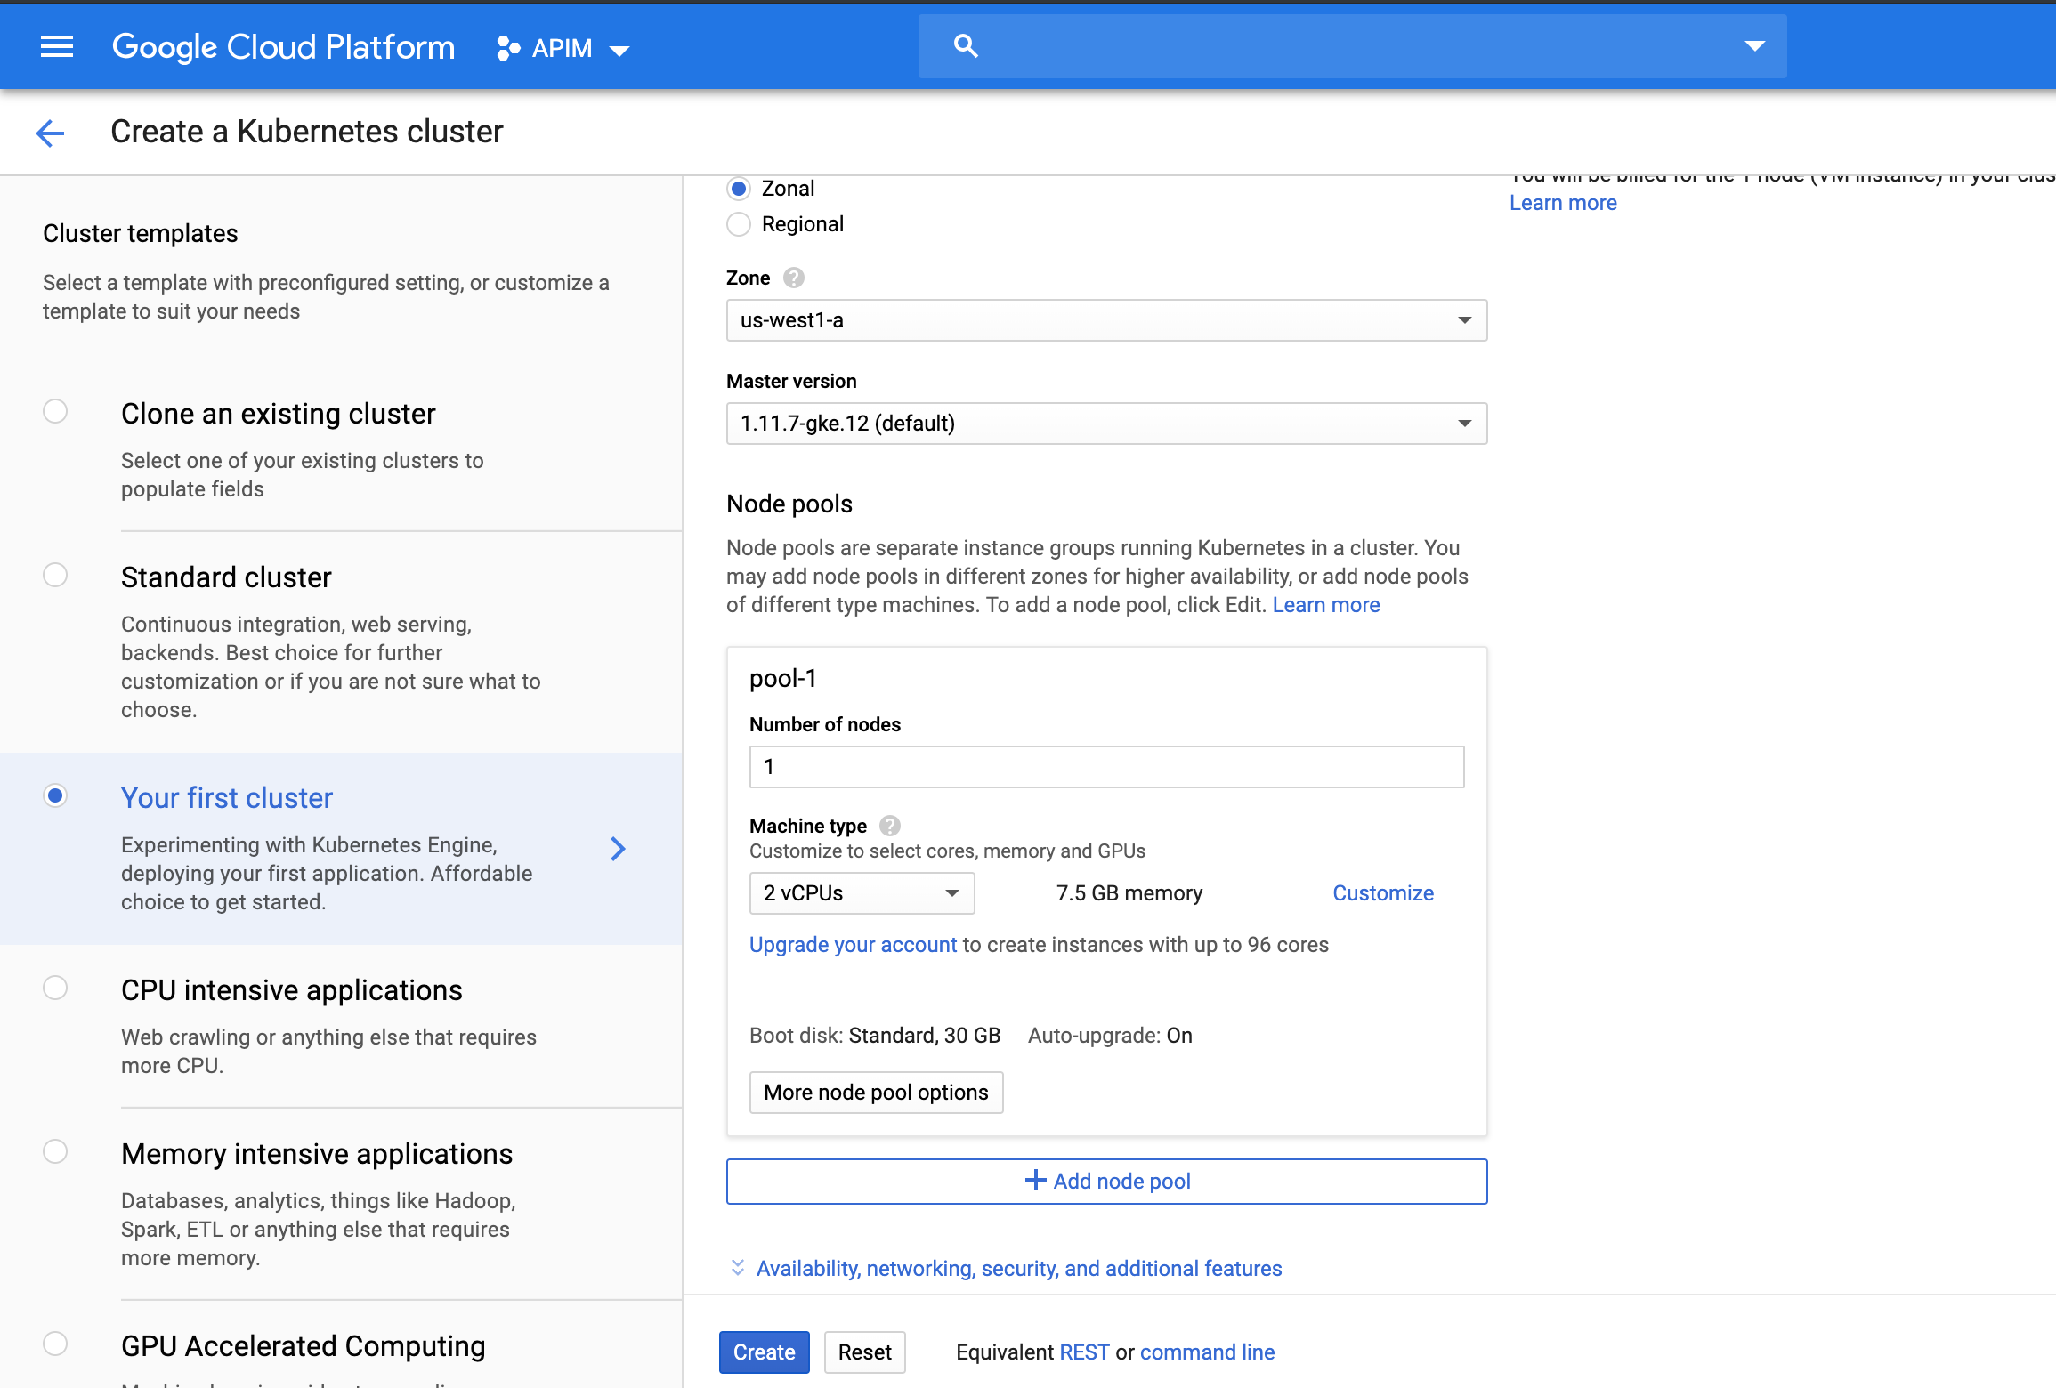

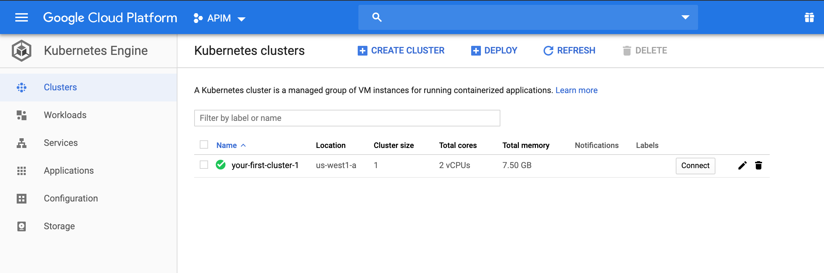

Clone the GitHub Project   
All the necessary YAML files and other additional documentation is hosted in GitHub web-based hosting service.

Connect to the Kubernetes cluster by clicking on “Connect” and then click on “Run in Cloud Shell”.

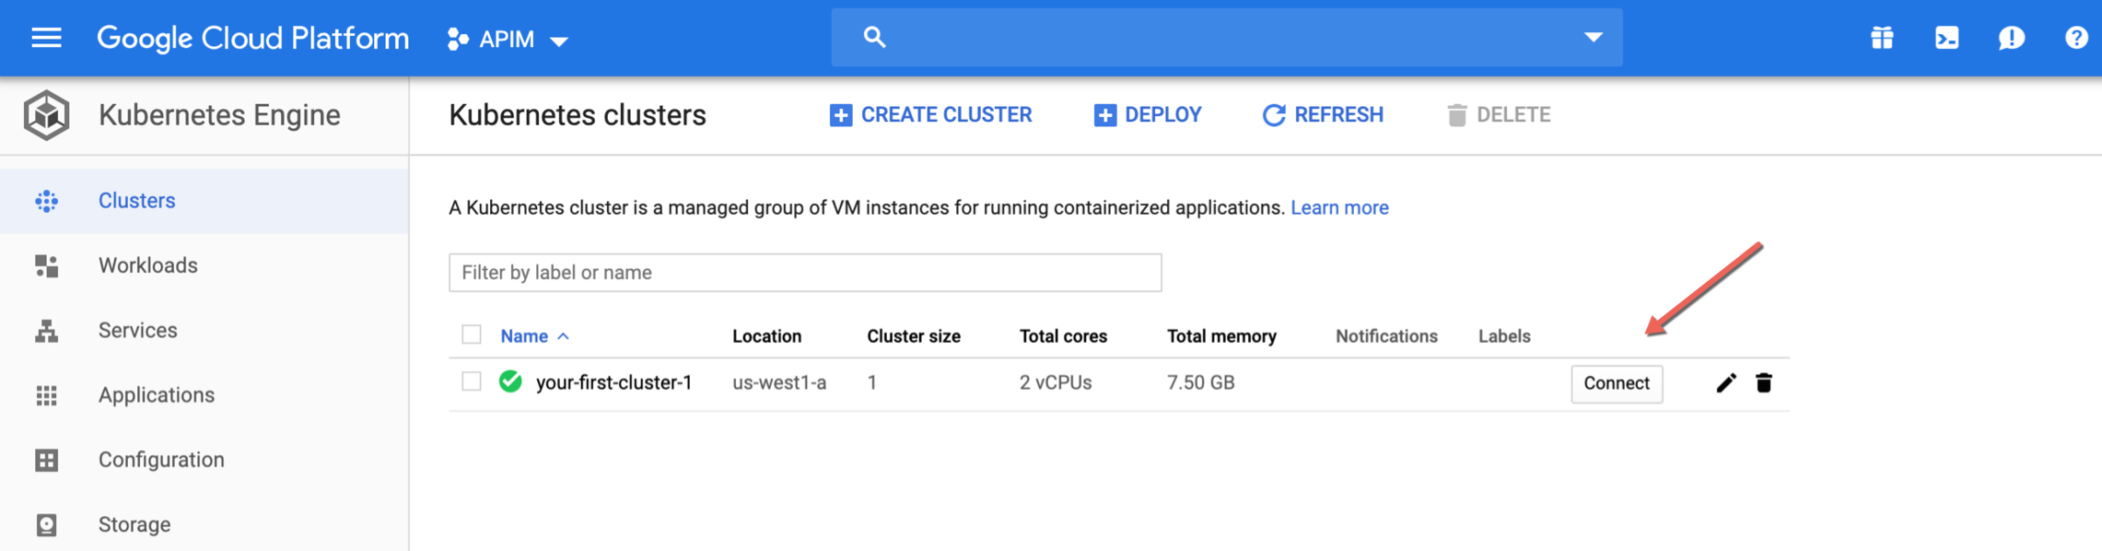

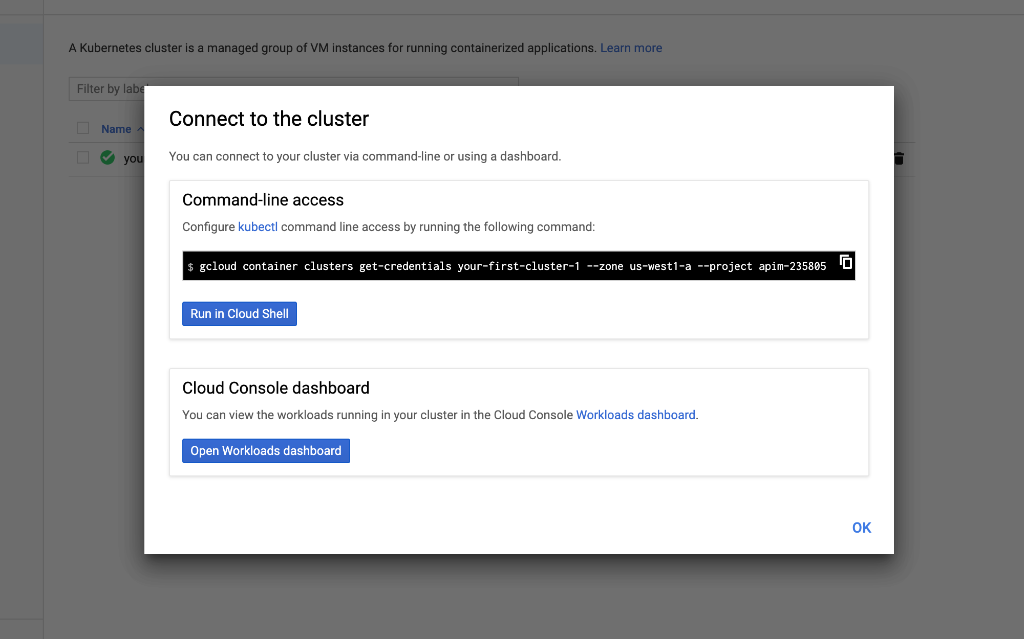

Hit return once the Cloud Shell show up at the bottom of the Web page.

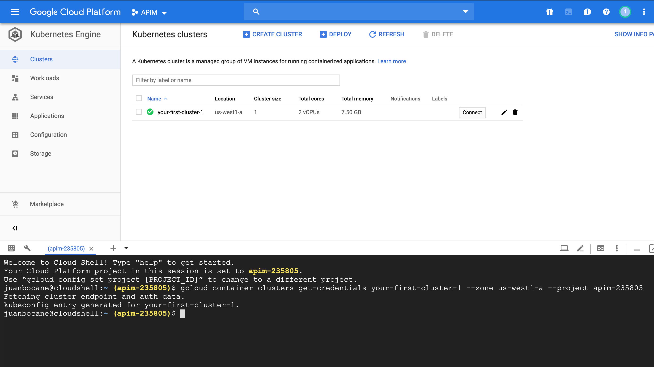

At the Cloud Shell prompt, in your home directory for you GCP project enter the command below. This command will clone all the necessary files from GitHub’s project.

$git clone https://github.com/matkeller/plano-k8s.git

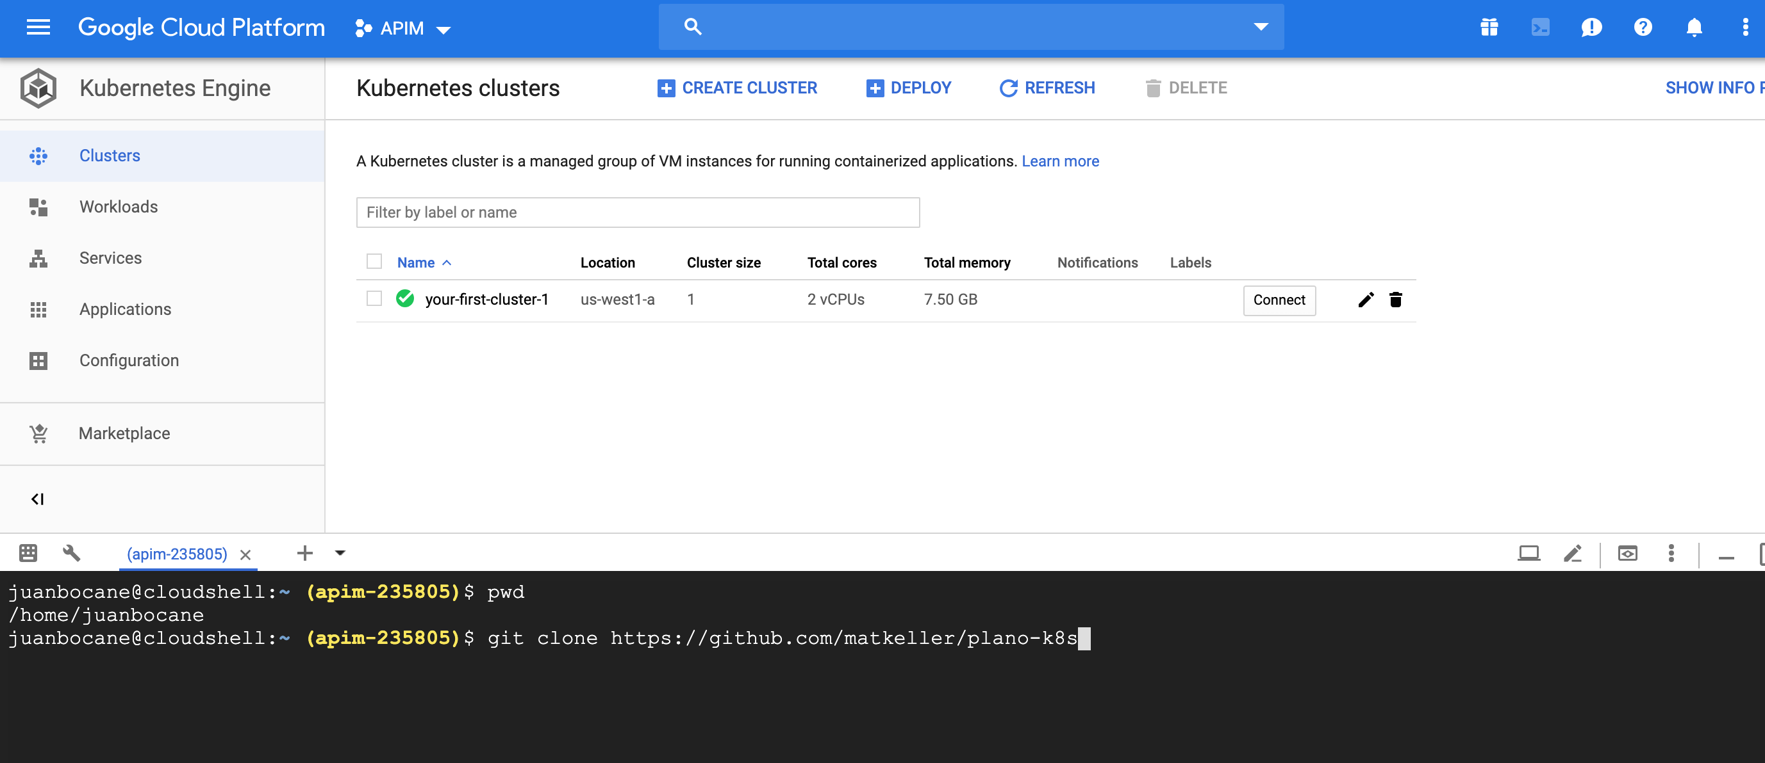

You can list all the project files by issuing the following commands:

$cd plano-k8s

$ls -las

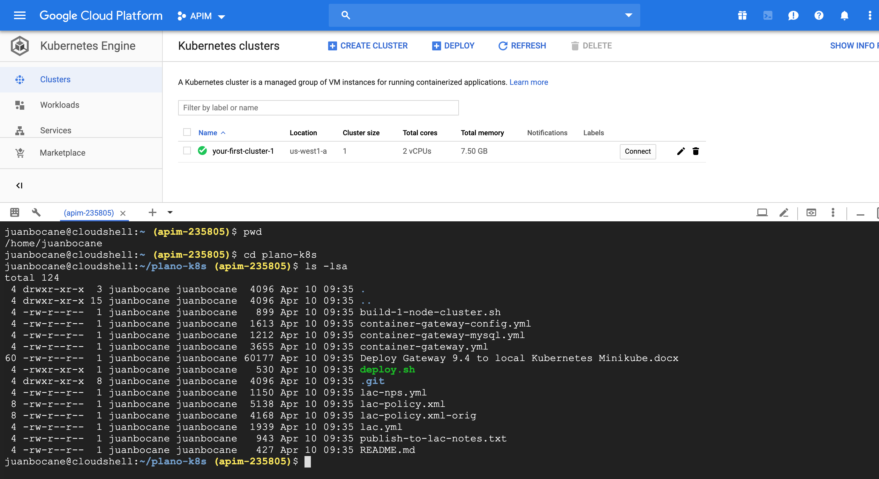

Add your API Gateway License

In file container-gateway-config.yml make sure you enter your APIM License. Request an API Gateway license to our support team. If working from the zip file you can skip this section. If you are working from freshly downloaded YAML files then you will need to prepare your license files. Please note you will need to take your license file from plain XML format first and then gzip it:

$ gzip license.xml

Then take this gz file and base64 encode it all onto one line of text:

$ openssl base64 -e -A -in license.xml.gz -out license.xml.gz.base64

Open this new file (license.xml.gz.base64) in a text editor and carefully paste it into the container-gateway-config.yml into the "ssg.license" field inside of a pair of double-quotes.  If you use a text editor that shows line numbers then please verify that the ssg.license is all on *one* line.

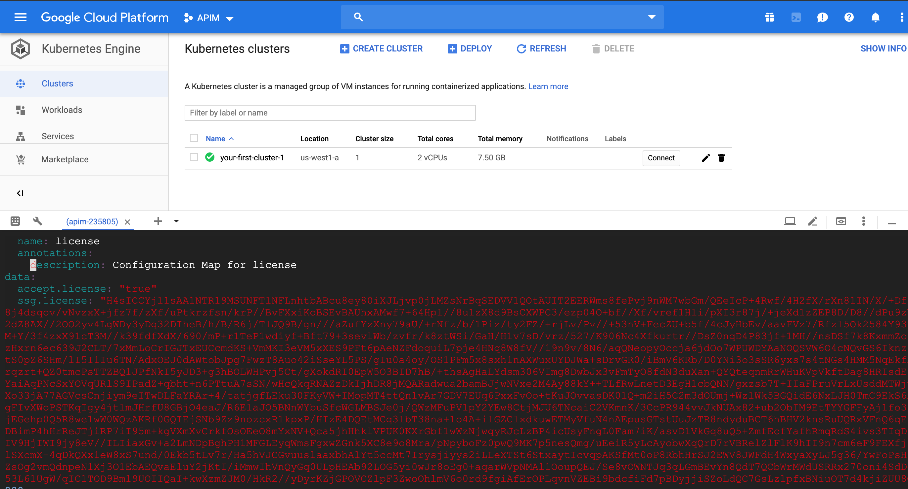

Run deploy.sh script

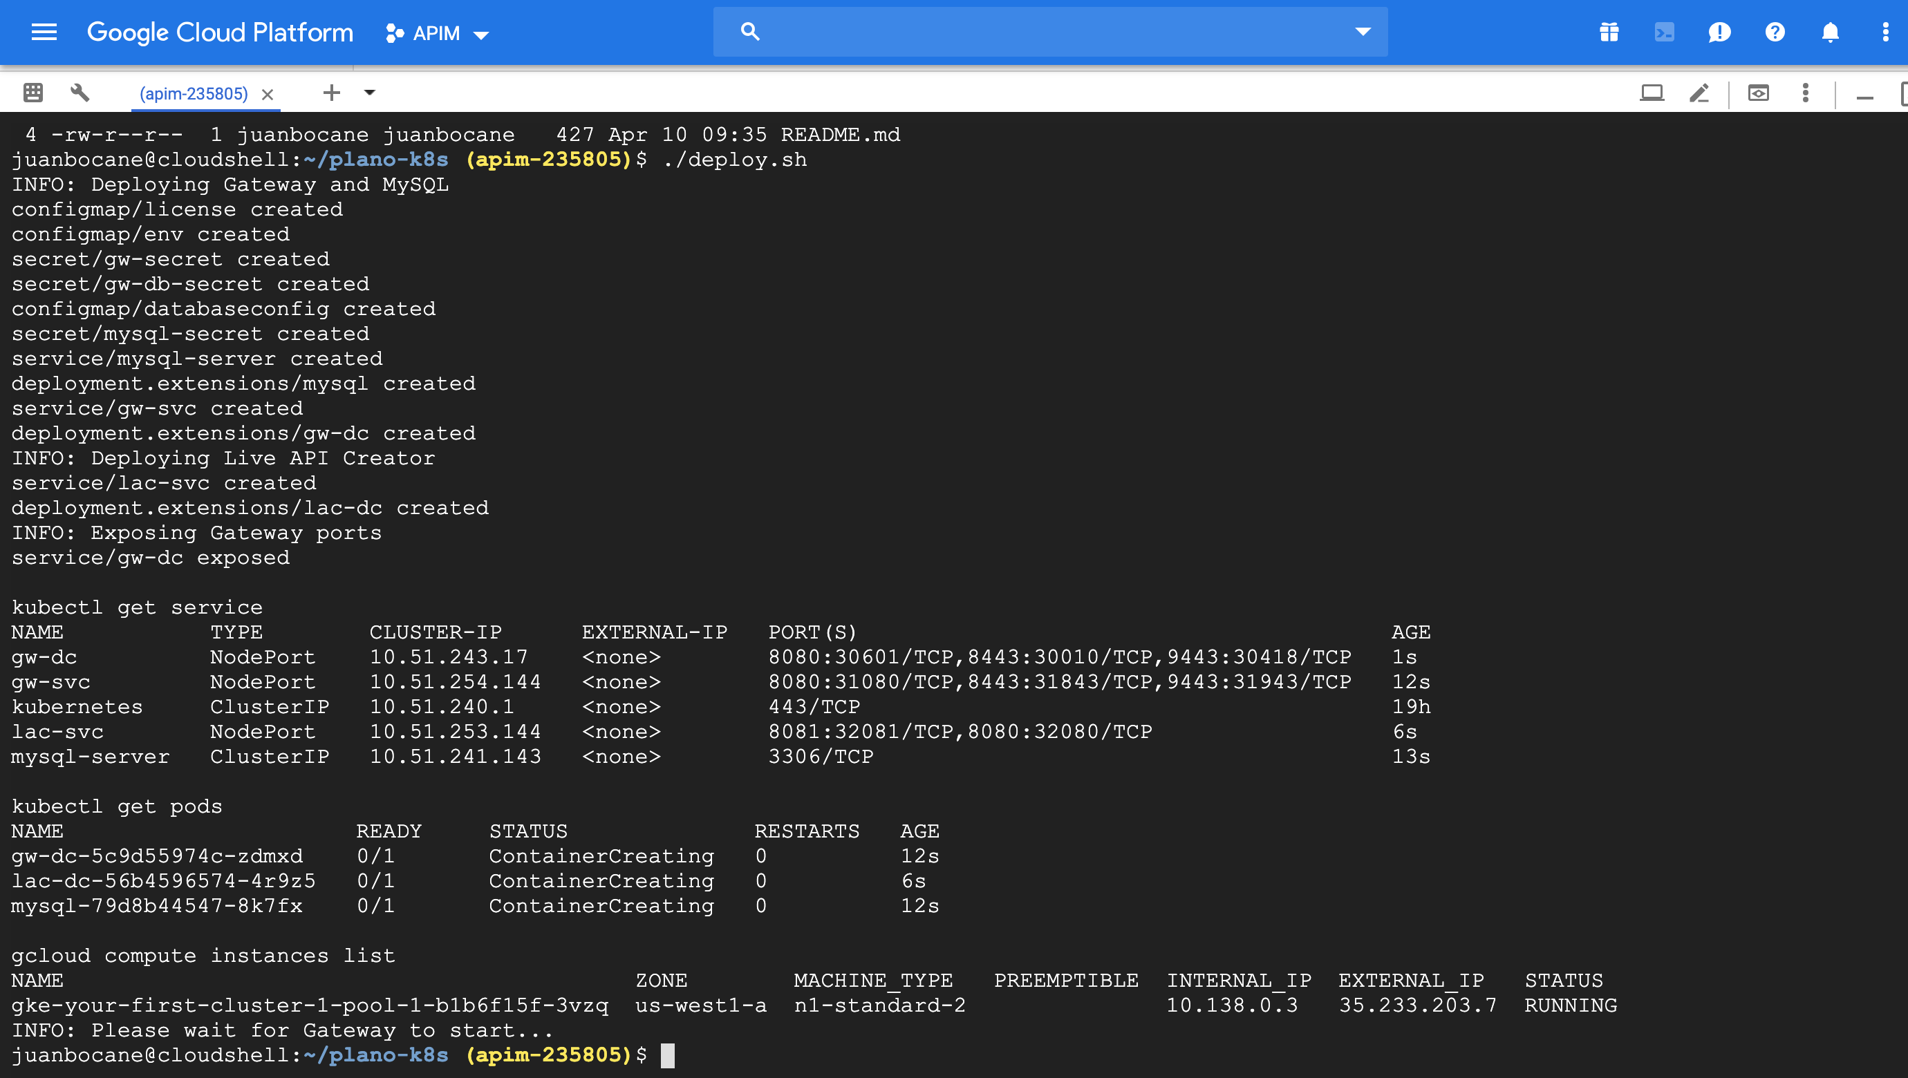

Continue running “kubectl get pods” to make sure the services are up and running (should show READY 1/1)

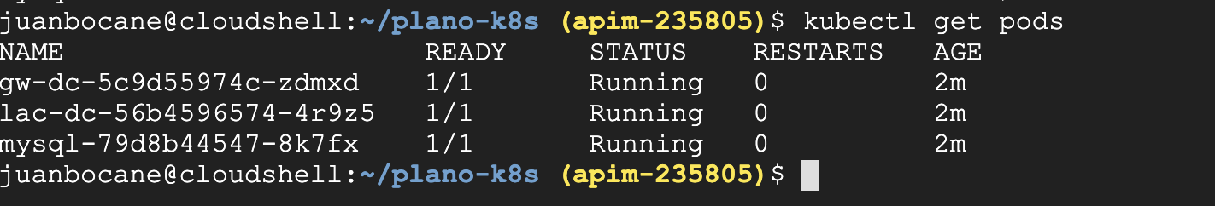

Configure GCP firewall

To allow your Policy Manager client to access your API Gateways and LAC applications you need to configure your GCP firewall to allow ingress access from your desktop external IP.

Go to Compute Engine – VM instances and double click on your Kubernetes cluster instance. Grab your external IP and internal IPs. You will need the external IP to connect to API Gateway from your Policy Manager client on port 31843. You will also need the internal IP… continue reading.

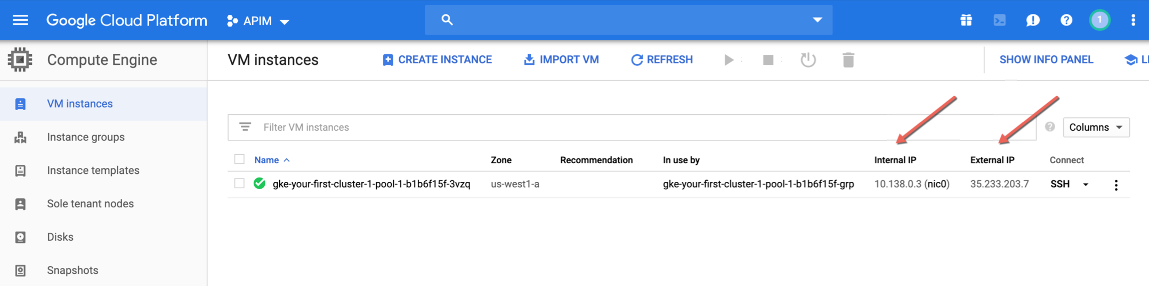

Scroll down to network interfaces and click on “View details”. On the left hand side click on “Firewall rules”.

Add your firewall rule:

Targets: All instances in the network

Source IP ranges: Your external IP address

Protocol and ports: Allow all

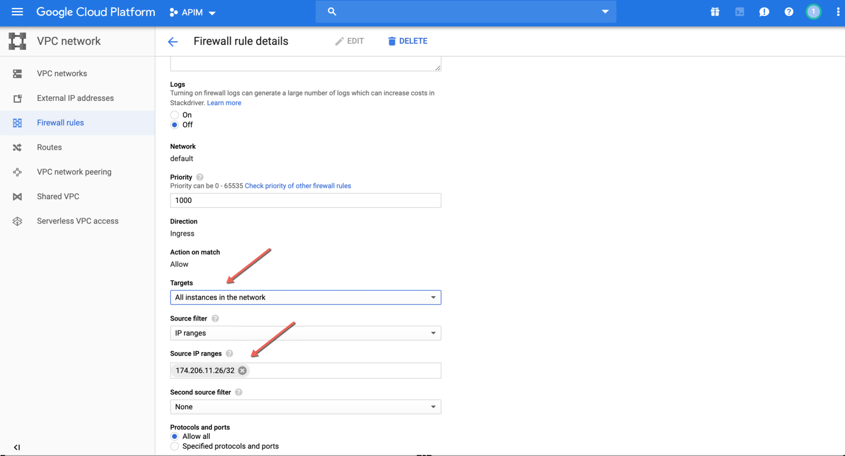

Launch Policy Manager

Launch Policy Manager on your desktop and login using the following credentials:

User Name: admin

Password: CAdemo123!

External IP: Your external IP

Port: 31843

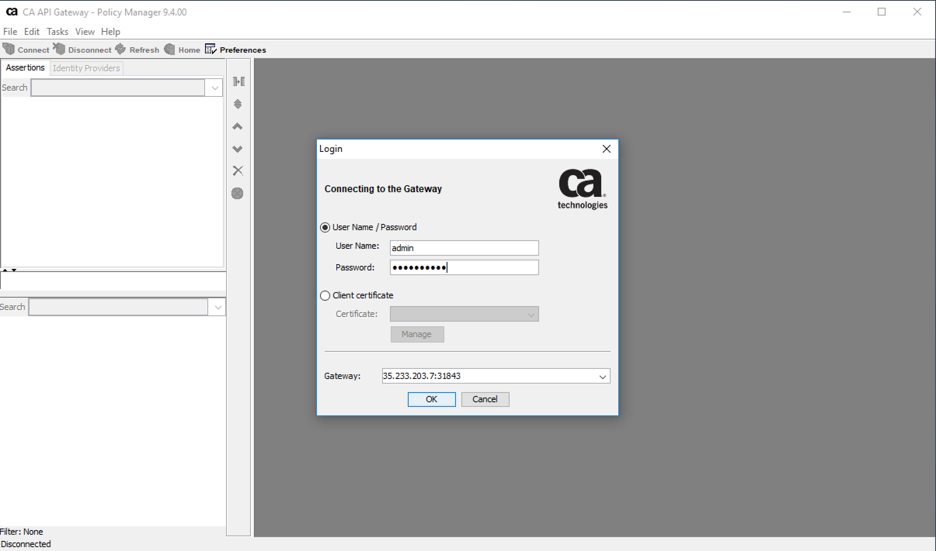

Ignore the certificate warning and click OK

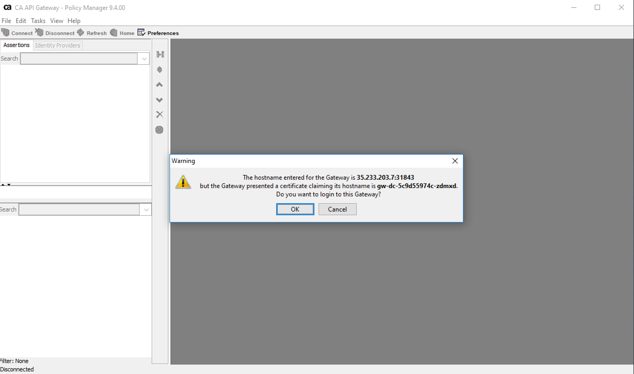

You should see the following UI

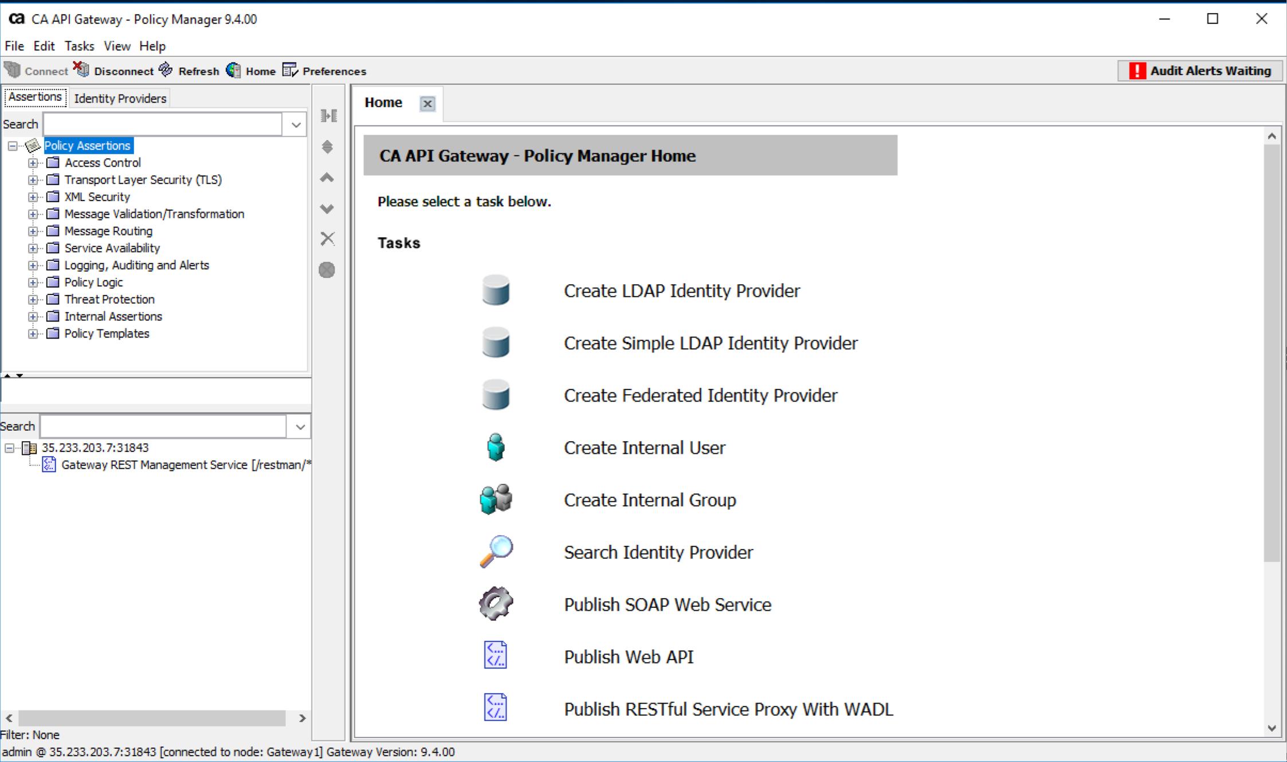

Push a API Gateway Policy via REST

You will need setup your desktop to work with GitHub Service (use Brew – please look this up in Google, varies based on your desktop OS)

* Edit the lac-policy.xml file and insert your *Internal IP* address on line 58.

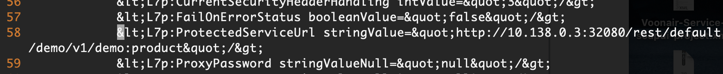

* Save and exit.
* Your IP addresses can be found in Google Cloud under "Compute Engine" and "VM Instances" or you can run the *gcloud* command in the cloud shell.



* Please fix the IP address in the curl command below with your External IP.
* Your IP addresses can be found in Google Cloud under "Compute Engine" and "VM Instances" or you can run the *gcloud* command in the cloud shell.
* You will need do the following steps on your desktop. Pull down the GitHub project files (same repo we to GCP using the Google cloud shell) with this command:

$git clone https://github.com/matkeller/plano-k8s.git

* cd to the newly created plano-k8s:

$cd plano-k8s

* You must cut/paste this curl command into a terminal on your machine. It will not run on the Google Cloud Shell unless you make some firewall changes.

$curl -k -u admin:CAdemo123! -H "Content-Type: application/xml" -X POST -d @lac-policy.xml https://[[YOUR_EXTERNAL_IP]]:31843/restman/1.0/services

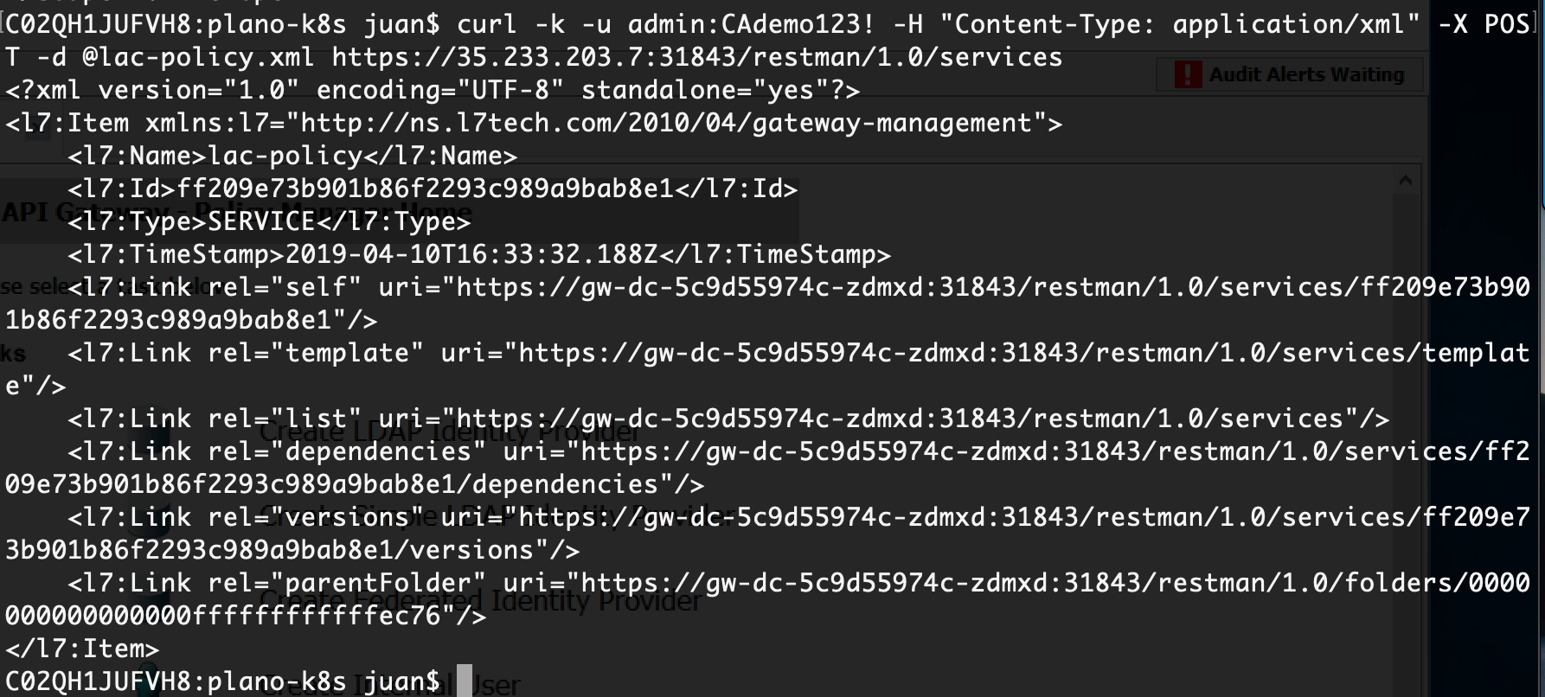

Note:

The following is already documented in publish-to-lac-note.txt (one of the files pulled from GitHub project).

Right click on your external IP on your Policy Manager to see the newly defined Policy

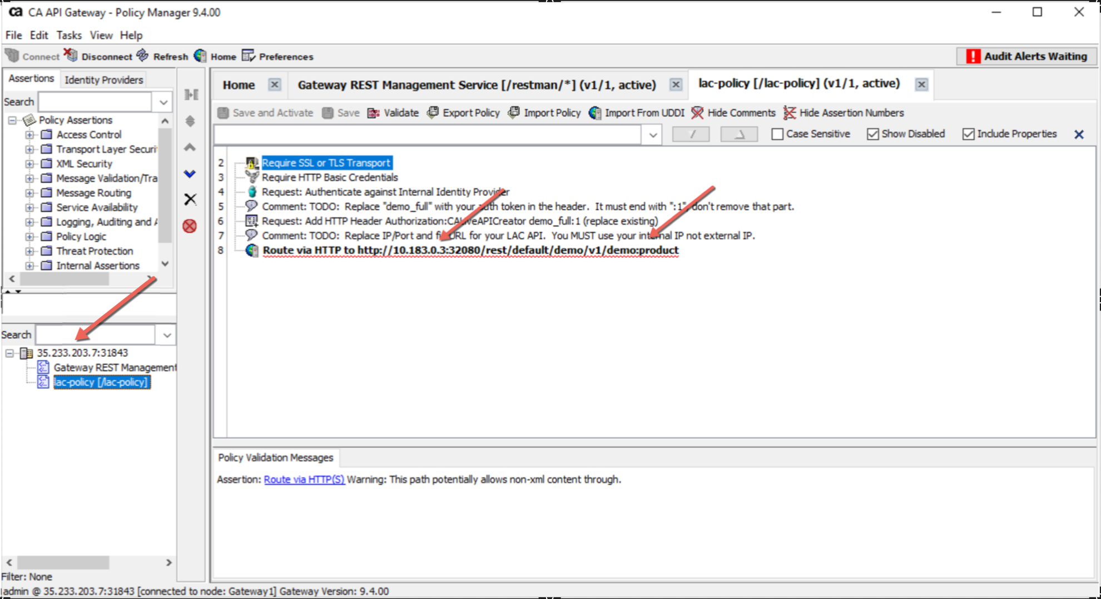

Login to LAC

Login to LAC with the following credentials:

<http://35.233.203.7:32080/>

Username: admin

Password: Password1

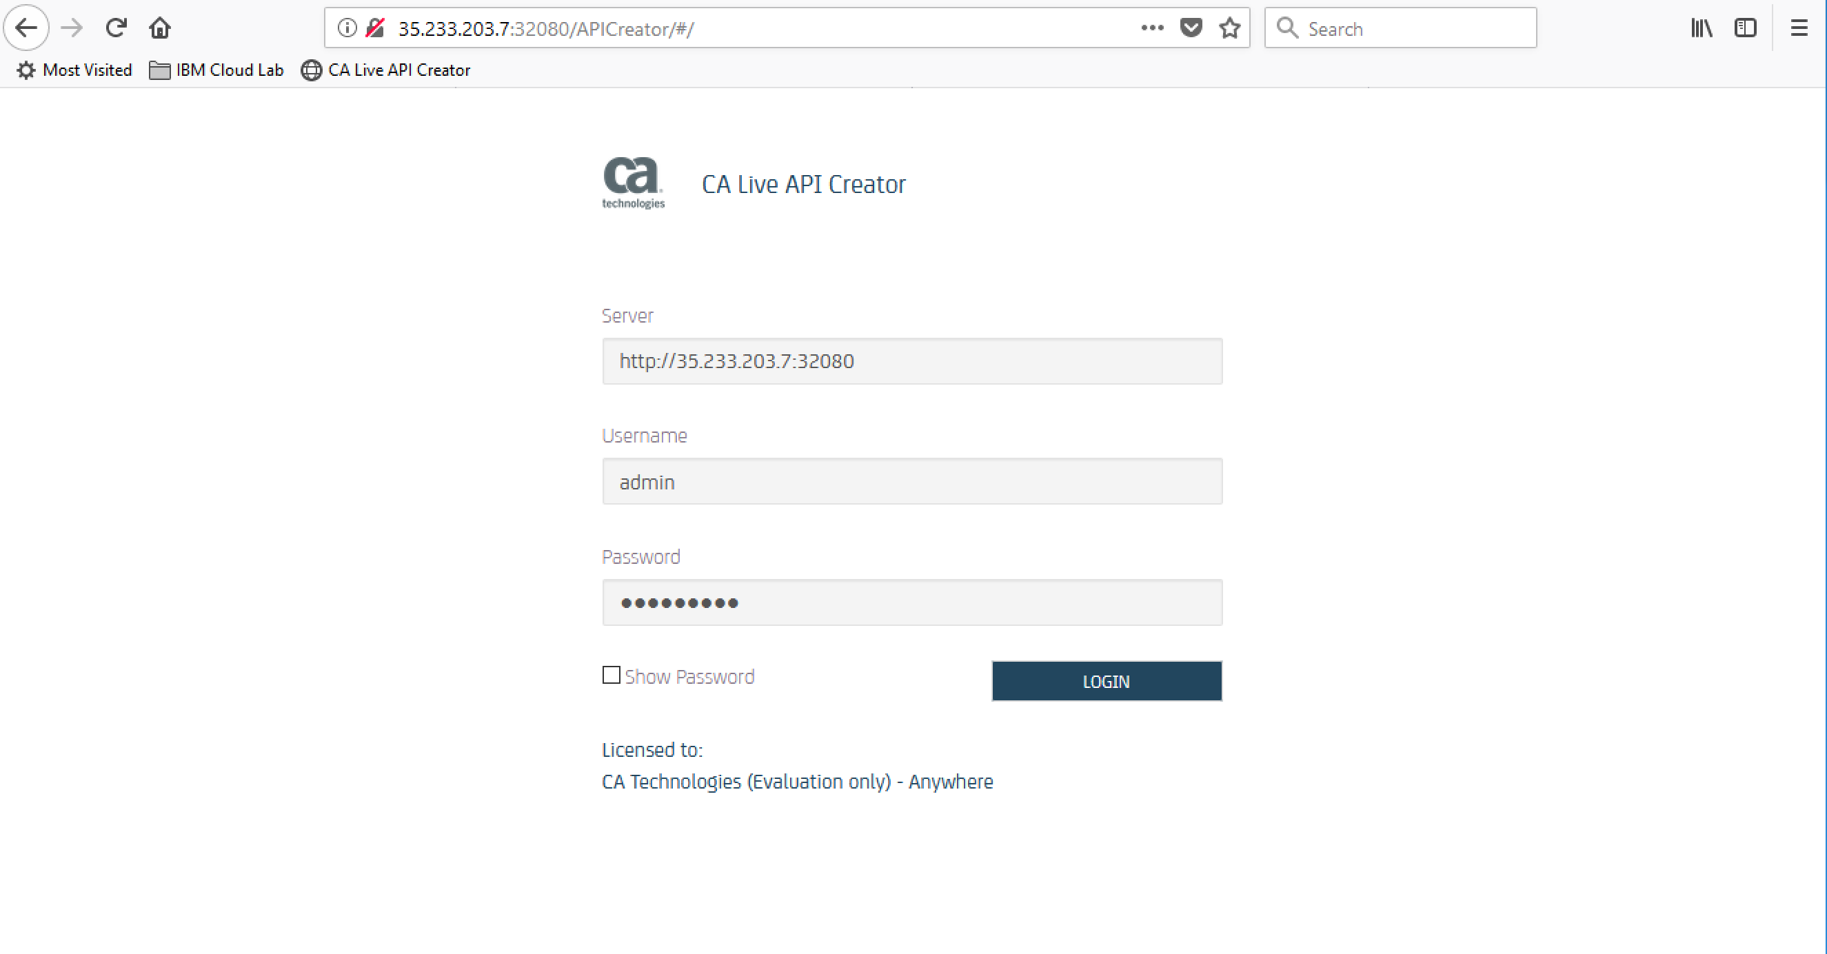

Choose Demo

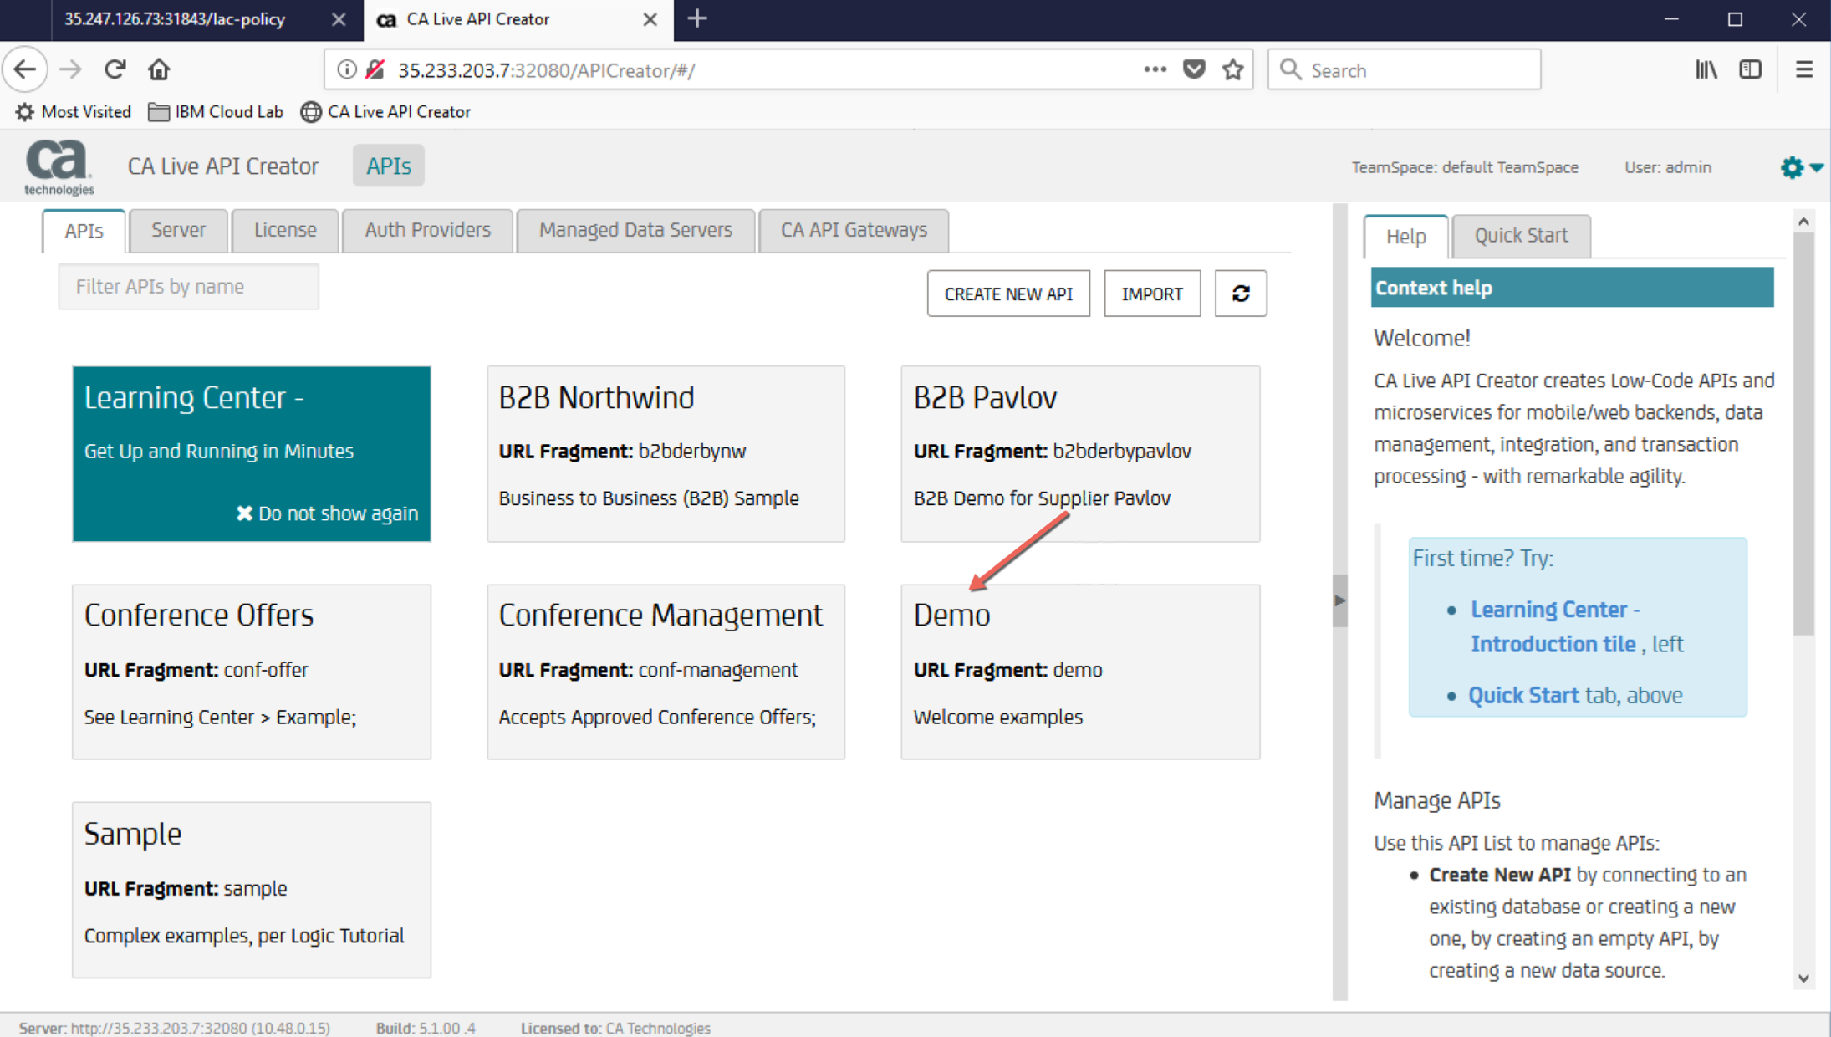

Choose demo:product and click on GET

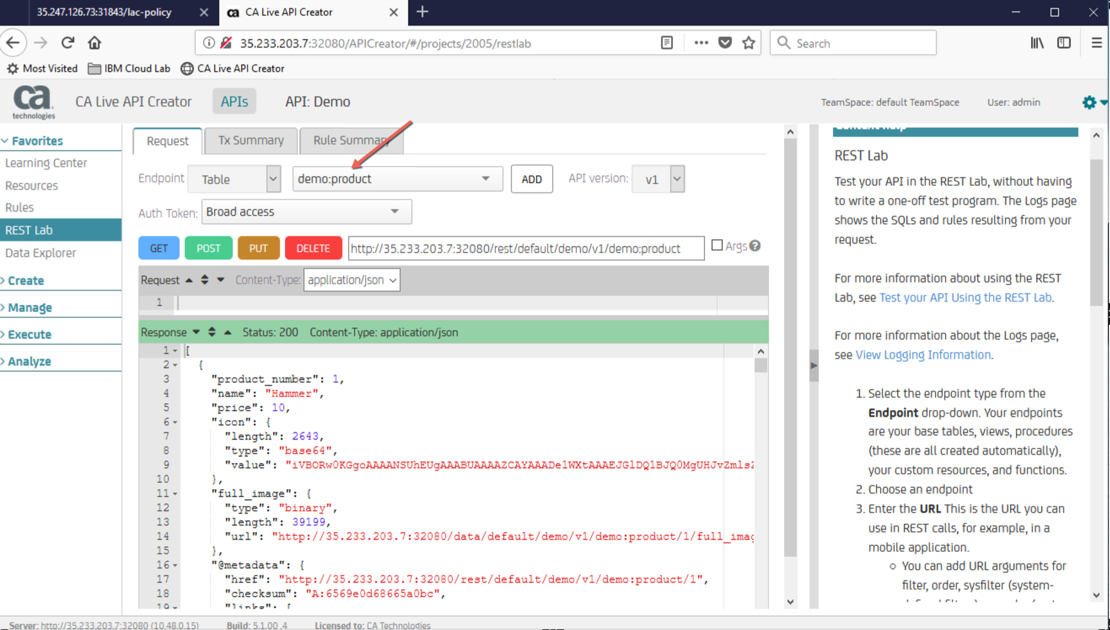

Send a REST call to LAC through API Gateway and confirm that *matches* the GET output above.

$curl -k -u admin:CAdemo123! https://35.233.203.7:31843/lac-policy

You can also try https://35.233.203.7:31843/lac-policy in a browser.

